To Answer
difference between linux and unix? both ops but what else (user group policy)

Alan’s Clark Wilson Notes & Answers: https://docs.google.com/document/d/1BEb3qs23S3_pusa9YWEY5TJVLMarMF-9XvfgspQ_wxc/edit

Summer 2011
Question 2
a) Describe the Access Matrix Model of security. Illustrate, using an example, how Unix access control lists (ACLs) can be represented in this model. Why is it reasonable to use this model to represent an access control policy mechanism? (15 marks)

- An Access Matrix is a formal security model of protection state in computer systems, that characterizes the rights of each subject with respect to every object in the system. Here, permissions are deﬁned for any kind of operation, not just read, write, execute. For example, permissions push, pop, etc., for a stack object.

- An access control list (ACL), with respect to a computer file system, is a list of permissions attached to an object. An ACL specifies which users or system processes are granted access to objects, as well as what operations are allowed on given objects. Each entry in a typical ACL specifies a subject and an operation. For instance, if a file has an ACL that contains (Alice, delete), this would give Alice permission to delete the file.

- An Access Matrix shows all possible flows of the state of a system at any given time.

b) A simple multilevel secure database management system is to be designed. Each row in a database table is assigned a separate security-level, and subjects at any security-level may access the table (but not necessarily every record in the table). For example, consider the following Customer-information table (custid is primary key).

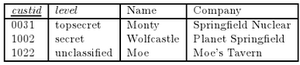

Given the usual ordering between the speciﬁed security levels, a secret process may read the Moe and Wolfcastle entries but not the Monty entry, and so forth. You should assume that when a new tuple is inserted into the table it is assigned the security-level of the subject inserting it.

i. Propose suitable multilevel security rules that govern how database operations UPDATE and SELECT should behave. (8 marks)

- A subject s attempts to SELECT a row i from table. Access is OK if security level of i <= security level of s.

- A subject s attempts to UPDATE a row i from table. Access is OK if security level of s <= security level of i.

c) Describe how the MLS DBMS mechanism in Part b) of this question could form part of a Chinese-Wall policy mechanism that ensured that a user cannot access customers records from competing companies. In answering the question be sure to explain why the Chinese Wall is enforced. (15 marks)

The companies from the MLS DBMS in part B could be could be placed into a table, defining what company information each company member has access to. As can be seen below, Monty working for Springfield Nuclear may have access to Springfield Nuclear information, but may not have access to Planet Springfield information.

_ ~ _ | Springfield Nuclear | Planet Springfield | Moe’s Tavern
Springfield Nuclear |  | X | X
Planet Springfield | X |  | X
Moe’s Tavern | X | X

Here the Chinese Wall policy is enforced to ensure that it is not possible for Springfield Nuclear worker Monty to pass on any Springfield Nuclear information to Planet Springfield worker Wolfcastle, leading to a conflict of interest.

Question 4
An Internet facing server gamer.com hosts an online multiuser game service on Port 666.

a) A string containing client data received at this port on gamer.com is passed by the service, without checking, to the C function:

void play ( char *str ) {
char buff [ 60 ];
strcpy ( buff, str );
// .....
}

Describe how a buﬀer-overﬂow in this function could enable a remote attacker gain control of the gamer.com host. (15 marks)

Notes
A buffer overflow occurs during program execution when a fixed-size buffer has had too much data copied into it. This causes the data to overwrite into adjacent memory locations, and depending on what is stored there, the behavior of the program itself might be affected.

The return address in the frame points to the next instruction to execute after the current function returns. This storage and retrieval of the address of the next instruction on the stack introduces a vulnerability that allows an attacker to cause a program to execute arbitrary code.

Successfully modifying the return address allows the attacker to execute instructions with the same privileges as that of the attacked program. If the compromised program is running as root, the attacker might use the injected code to spawn a superuser shell and take control of the machine. In the case of worms, a copy of the worm program is installed, and the system begins looking for more machines to infect.

Answer 1
strcpy causes a buffer overflow into FP and RET. Here the buffer overflow causes the RET address to be overwritten, where the attacker provides their own RET address, eg. to execute a shell. By experimenting with the right parameter value (SH-HACK2), an attacker can cause a buffer overflow and get the program to execute their own code. If the program is a suid-root shell then the attacker gets access to a root shell, and essentially has access to the entire system.

Answer 2 (Simon’s)
Should identify why this program has a buﬀer overﬂow and give an outline of how the buﬀer overﬂow is carried out: can cause new instructions (eg a execv) to be pushed on the stack and executed (assuming that the argv carefully overwrites the saved stack frame pointer, etc.)

Should explain what the consequences of the buﬀer overﬂow is, that is, that the attacker can provide the attacking argv as form value on the web-site and thereby get the server to execute an instruction speciﬁed in the argv by the attacker.

b) There is a concern about SYN-ﬂood based denial of service attacks on gamer.com. The administrator uses a (ﬂawed) implementation of SYN-cache whereby the state associated with a half-open connection is stored in the hashtable bucket indexed as h(i.p), where h() is a one-way hash function, i is the IP address of gamer.com and p is the requested port on gamer.com. Describe how an attacker can still carry out a SYN ﬂood on this host and outline how the SYN-cache scheme should have been implemented. (15 marks)

In this case, the half-open connections are not being stored in a secure manner. They are being stored as the hash(ip address of gamer.com, requested port). This is not secure because an attacker can easily figure out the hash values stored and thus override legitimate half-open connections from legitimate visitors of gamer.com, in order to carry out a Denial of Service attack.

The hash value on the incoming packet should have been computed using the source and destination addresses, the source and destination port, and a randomly chosen secret. Here the attacker will not know which bucket packets are being placed in.

c) Suppose that the probability of a SYN-ﬂood based denial of service attack on gamer.com during a calendar year is 0.01, with a resulting loss of earning of $100,000. Deploying a SYN-cache reduces this probability to 0.001, however, it is recommended that the server is upgraded (once oﬀ cost $900), in order to support the SYN-cache processing requirements. Suppose that SYN-cookies entirely eliminate the risk of SYN-ﬂood based denial of service, however, their continual use impact connection performance with a yearly loss of earnings of $5,000.00.

Use this information to carry out a Risk Assessment and advise the owners of gamer.com on how best to mitigate the risk of denial of service. (15 marks)

- Option 1
  - Risk-flood = 0.01 * 100,000 = 1,000
- Option 2
  - Risk-cache = 0.001 * 100,000 = 100
  - Upgrade to SYN-cache cost = 900
- Option 3
  - Upgrade to SYN-cookies = 5,000 yearly

From the above Risk calculations, it is clear that the current system risk amounts to $1,000 per year. Upgrading the system to allow SYN-cache would cost $100 per year, with a once off $900 cost i.e. 1,000 - (100 + 900) = 0. There would be 0 savings made in the first year due to the server upgrade, however there would be savings of 900 per year thereafter. On the other hand SYN-cookies would completely remove this risk, however this would come at a cost of 5,000 per year.

From the above assessment, it can be clearly seen that option 2 is the best option. While a breakeven is achieved in the first year, clear savings are made in the following years.

Question 4
c) It is decided that it would be better to implement the Printer Server using the JAAS framework. The Printer Server PrSvr.jar includes the following code fragment.

LoginContext lc = new LoginContext("CS4253", new TextCallbackHandler());
lc.login();
subject s= lc.getSubject();
PrivilegedAction lpr= new PrintAction();
subject.doAs(s,lpr);
lc.logout();

where a PrintAction is a class that implements basic printing using the getPrintJob() method in the java.awt.Toolkit class Explain the operation and purpose of each line of the above code. (15 marks)

-- get userid & password from user & pass to login module to authenticate subject
LoginContext lc = new LoginContext("CS4253", new TextCallbackHandler());

-- invokes all of the loaded login modules, where each one attempts to authenticate subject
lc.login();

-- get current subject
subject s= lc.getSubject();

-- create new print (privileged) action
PrivilegedAction lpr= new PrintAction();

-- execute action as subject
subject.doAs(s,lpr);

-- log the fudge out
lc.logout();

Summer 2010
c) The website owners have a choice of deploying the web-server plus DBMS on either a standard Linux server or on an SELinux server that provides Type Enforcement based access control. Advise the website owners on the choice and illustrate your answer by comparing a Linux user-group policy versus a Domain Deﬁnition Table. (15 marks)

Linux user-group policy
Image below to explain.

Domain Deﬁnition Table
A Domain Definition Table (DDT) defines the allowable access rights within a domain. A DDT provides fine grained control by allocating different types to different domains. Here each domain has limits on the privileges allowed to each of the different types, and no other domain is accessible from within a particular domain ie. if a domain is compromised, there is limits on the amount of damage an attacker can do.

Summer 2009
Question 5
c) Develop suitable Java security policy grant entries for the following requirements.

i. Any code signed by the public key simon may have read and write access to ﬁles under /usr/home/simon/. (5 marks)
grant signedby "Simon" {
permission java.util.PropertyPermission "user.home", "read";
permission java.io.FilePermission "$(user.home)${/}simon/* ", "read, write",
signedby “Simon”
}

ii. Anybody may read and write ﬁles in /tmp/. (5 marks)
grant {
permission java.util.PropertyPermission "tmp", "read";
permission java.io.FilePermission "/tmp/* ", "read, write";
}

iii. Any jar ﬁles or classes from source http://cs.ucc.ie may have read access to any ﬁle in the directory /usr/home/simon/cs. (5 marks)
grant codebase "http://cs.ucc.ie” {
permission java.util.PropertyPermission "user.home", "read";
permission java.io.FilePermission "$(user.home)${/}simon/cs/* ", "read, write";
}

iv. The principal simon, authenticated in Kerberos domain CSDOMAIN, may read and write ﬁles in /tmp/. (5 marks)
grant {
Principal javax.security.auth.KerberosPrincipal “CSDOMAIN”
permission java.util.PropertyPermission "tmp", "read";
permission java.io.FilePermission "/tmp/* ", "read, write";
}

Summer 2008
Question 3
a) A Unix based implementation of the Tetris game maintains information on player scores in the ﬁle /etc/scores. The game is SUID root and is executable by all, the scores ﬁle is owned by root and is readable and writable only by its owner.

i. Why is the game SUID root? Explain how the SUID permission operates. (7 marks)

- So that for any user playing the game, the program can update the highscores file with the player’s score.

- When a program ﬁle has the setuid root permission set then during execution the user id of the invoking process becomes root.

ii. Discuss the dangers of using SUID root and suggest a safer way of securing the program and ﬁle. (8 marks)

- SUID is dangerous because any user can run the program with “root” privileges ie. the user will essentially have access to the etc/passwd file. Any program granted SUID privileges must be thoroughly inspected and totally trusted. The scripts must be readable by the user who executes them, so any small bug in the script can be exploited, and this exploit in turn may be used to compromise the system.
- I would suggest using a Type Enforcement Policy as a safer way of securing the program and file.

b) Describe the Type Enforcement protection model. Using the Tetris program above as an example, explain how and why Type Enforcement can provide stronger protection than a SUID based mechanism. (15 marks)

- In a Type Enforcement Policy, every subject (process) has an associated protection domain. Domains entered by executing a program attached to that domain. Domains are like sandboxes that are used to limit the access that a program has to resources, meaning that the process running the program has limited privileges ie. the user only has the most basic requirements to run the program and no more.
- This limiting of the users privileges ensures that the user does not have any extra permissions that they do not need, which may in turn be used for malicious means.
- So even if a program is running as SUID root, as long as it is in a protections domain with limited privileges, the attacker will have limited access to other system services etc. which are within other protection domains.

c) The SUID root Tetris program described Part (a) above may take as parameter a path to a scores ﬁle (to override default /etc/scores path). This program has behaviour:

void main (int argc, char* argv[]}{
char scores[12];
strcpy(scores, argv[0]);
// argv[0] gives path to scores file
...// Step 0. play game;
...// Step 1. open scores file to obtain user’s last score;
...// Step 2. create/open temporary file stmp in same directory as scores;
...// Step 3. open scores file, copy contents to stmp and current score;
...// Step 4. close files and rename stmp as score file;
}

Identify and explain potential security vulnerabilities in this design. (15 marks)

- This design is open to a buffer overflow and stack smashing attack.
- Answered in Summer 2011
- Above also allows an attacker to overwrite the scores file.

Question 4
b) Write a note on computer viruses, considering their operation and infection. Discuss the eﬀectiveness the following techniques in defending against viruses: virus checkers, codesigning, security-kernels. (15 marks)

- Virus: A program or code that replicates; i.e., infects another program, boot sector, partition sector, or document that supports macros, by inserting itself or attaching itself to that medium. Most viruses only replicate, though, many do a large amount of damage as well
- Worm: A program that makes copies of itself; for example, from one disk drive to another, or by copying itself using email or another transport mechanism. The worm may do damage and compromise the security of the computer. It may arrive in the form of a joke program or software of some sort.
- Trojan Horse: A program that neither replicates nor copies itself, but causes damage or compromises the security of the computer. Typically, an individual emails a Trojan Horse to you-it does not email itself-and it may arrive in the form of a joke program or software of some sort.

- The SQL Slammer Worm caused a denial of service on some Internet hosts and dramatically slowed down general Internet traﬃc,

- Virus checker allows one to search and locate viruses on your computer, however they are only as good as their virus databases, which should be up to date.
- Code Signing: While this does tie code to a key, there is the problem of how to determine whether the key is trustworthy and whether it has ever signed malicious code in the past, even by accident.
- Security-kernel: the centre for security within a computer, which works as a part of an operating system to prevent unauthorized access to, or use of, the system and contains criteria that must be met before specified programs can be accessed.

Autumn 2006
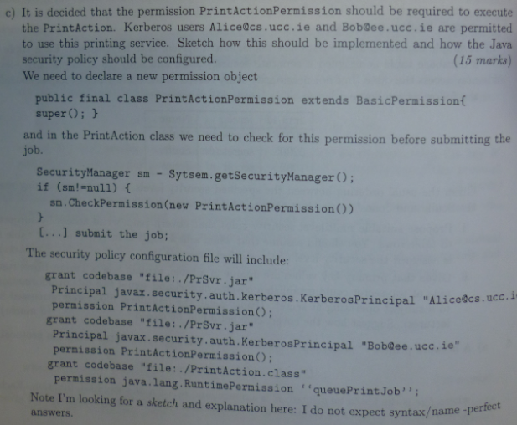

Summer 2005
Question 3
a) If I was not too worried about Trojan Horses and covert channels how could I use the user-group policy mechanism in Unix to implement a rather crude form of multilevel security? Explain your answer and discuss its eﬀectiveness. (15 marks)

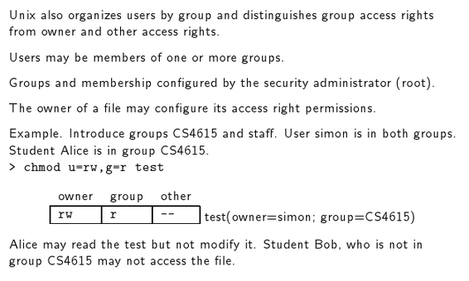

Summer 2002
Question 2
(b) A stock exchange system holds information on competing public oil companies shell and esso and on competing public banks aib and boi. Market Analysts Alice and Bob use this system. Outline how the standard Unix protection mechanisms might be used to uphold a Chinese Wall policy on this system. Your answer should include a suitable conflict of interest relation, identification of appropriate users and groups, sample protection profiles for company files and a description of how user authorizations are maintained. Note any vulnerabilities in your approach. (15 marks)

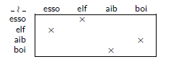
Here we have two users Alice & Bob. We also have four different groups shell, esso, aib & boi.

Assume Alice is working for aib & Bob is working for boi. Alice may not access boi information as this will lead to a conflict of interest. Same for Bob. Alice may access shell or esso information, but may not access both. Same for Bob.

Here the Chinese Wall policy is enforced to ensure that it is not possible for aib worker Alice to pass on any aib info to boi worker Bob, leading to a conflict of interest.However it must be noted that Alice & Bob can still conduct insider trading outside of the parameters of security system.

