- A keystore is a repository of keys and certificates, and is used to look up the public keys of the signers specified in the policy file ("terry" and "chris" in this example).
- Time of Check to Time of Use(TOCTOU)
  - A type of software bug caused by changes in a system between the checking of a condition (such as a security credential) and the use of the results of that check. This is one example of a race condition.

JAAS
- In a nutshell - JAAS uses pluggable authentication
- JAAS is the Java implementation of the standard Pluggable Authentication Module (PAM) information security framework. JAAS was introduced as an extension library to the Java Platform.
- JAAS authentication is performed in a pluggable fashion. It can simplify your Java security development by permitting applications to remain independent from their security while security mechanisms are added to an application without modifying existing code or application structure.

JAAS can be used for two purposes:
- for authentication of users, to reliably and securely determine who is currently executing Java code, and
- for authorization of users to ensure they have the access control rights (permissions) required to do security-sensitive operations.

Stack Smash
Stackguard:
- A gcc extension that puts a random ’canary word’ in front of the RET value on the stack. This is checked just before the function returns and if diﬀerent then the program exits. Can be bypassed if attacker can guess the canary word and place it on the stack

MLS
Covert Channels
- A covert channel is a type of computer security attack that creates a capability to transfer information objects between processes that are not supposed to be allowed to communicate by the computer security policy

- A covert channel is hidden from the access control mechanisms of secure operating systems since it does not use the legitimate data transfer mechanisms of the computer system such as read and write, however, they can often be detected by monitoring system performance.

- Ordinary things, such as existence of a file or time used for a computation, have been the medium through which a covert channel communicates

- The possibility of covert channels cannot be completely eliminated, although it can be significantly reduced by careful design and analysis.

- For an MLS system to keep secrets perfectly, there must be no possible way for a Top Secret process to transmit signals of any kind to a Secret or lower process.

- The detection of a covert channel can be made more difficult by using characteristics of the communications medium for the legitimate channel that are never controlled or examined by legitimate users. For example, a file can be opened and closed by a program in a specific, timed pattern that can be detected by another program, and the pattern can be interpreted as a string of bits, forming a covert channel. Since it is unlikely that legitimate users will check for patterns of file opening and closing operations, this type of covert channel can remain undetected for long periods.

- Easy to extend to communicate secret m-bit value to unclassiﬁed by creating/checking for multiple ﬁles, each one corresponding to one bit position.

Removing file creation covert channel:

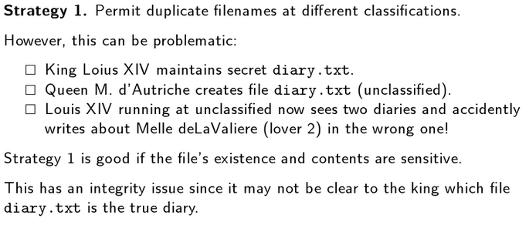

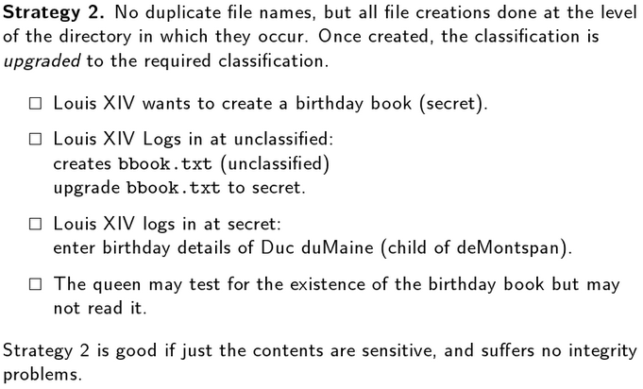

Other potential covert channels:
- directory listing in increasing/decreasing order.
- If ﬁd values are generated sequentially then a high level Trojan horse can signal a low-level process by creating a large number of ﬁles. A solution is to use a secure pseudo-random number generator to generate ﬁds.

Bell-LaPadula Model
- Defined by no read up, no write down.

- Supports confidentiality.

- With Bell-LaPadula, users can create content only at or above their own security level (i.e. secret researchers can create secret or top-secret files but may not create public files; no write-down). Conversely, users can view content only at or below their own security level (i.e. secret researchers can view public or secret files, but may not view top-secret files; no read-up).

Limitations
- Only addresses confidentiality, control of writing (one form of integrity), ★-property and discretionary access control
- Covert channels are mentioned but are not addressed comprehensively
- The tranquility principle limits its applicability to systems where security levels do not change dynamically. It allows controlled copying from high to low via trusted subjects.

The transfer of information from a high-sensitivity document to a lower-sensitivity document may happen in the Bell–LaPadula model via the concept of trusted subjects. Trusted Subjects are not restricted by the ★-property. Untrusted subjects are. Trusted Subjects must be shown to be trustworthy with regard to the security policy.

Biba
Biba Model
- Intuition: high integrity data may not in any way be based on/inﬂuenced by low-integrity data.

- In general the Biba model was developed to circumvent a weakness in the Bell–LaPadula model which only addresses data confidentiality.

- This security model is directed toward data integrity.

- Defined by no read down, no write up.

- A General may write orders to a Colonel, who can issue these orders to a Major. In this fashion, the General's original orders are kept intact and the mission of the military is protected (thus, "no read down" integrity). Conversely, a Private can never issue orders to his Sergeant, who may never issue orders to a Lieutenant, also protecting the integrity of the mission ("no write up").

DTE
- DTE (Domain & Type Enforcement)
- Domains are like sandboxes that are used to limit the access that a program has to resources.
- A Domain Definition Table (DDT) defines the allowable access rights within a domain.
- DTE like MLS, but DDT has finer grained control.
- In MLS, user access is very coarse-grained. For example, a topSecret subject can access all top-secret information. (though we can limit this to an extent by using compartments).

Difference between MAC & DAC
- MAC In the Mandatory Access Control (MAC) model, users are given permissions to resources by an administrator. Only an administrator can grant permissions or right to objects and resources. Access to resources is based on an object's security level, while users are granted security clearance. Only administrators can modify an object's security label or a user's security clearance.

- DAC In the Discretionary Access Control (DAC) model, access to resources is based on user's identity. A user is granted permissions to a resource by being placed on an access control list (ACL) associated with resource. An entry on a resource's ACL is known as an Access Control Entry (ACE). When a user (or group) is the owner of an object in the DAC model, the user can grant permission to other users and groups. The DAC model is based on resource ownership.

Quick Definition
- Mandatory Access Control (MAC): subjects and objects have security attributes that can not be changed by the user.
- Discretionary Access Control (DAC): subjects and objects have security attributes that can be changed by the user.

Difference between DDT and Access Control Matrix
- DDT uses domains and types.

- Access Matrix uses subjects and objects.

Access Control
Access Control Matrix
- Table with list of subjects and their security rights with respect to every object in the system.

Associate an Access Control List (ACL) with each object
- List of permissions attached to an object.
- ACL gives details about who may access (and how) the object.
- ACLs may be modified by the owner; more flexible than groups.
- ACL checked by protection mechanism before access is granted

Setuid permission in Unix
- When a program ﬁle has the setuid root permission set then during execution the user id of the invoking process becomes root.
- i.e. SUID programs are those programs which run with the permissions and privileges of root user at the time of execution. So, when the program is executed, it’s granted the privileges of root user.

Policy Implementation: Centralised Policy, Centralised Mechanism
- Traditionally, security policies and mechanisms are centralised using a single reference monitor that mediates all accesses.

- Having each machine responsible for its own policy makes interoperation diﬃcult as changes in one policy need to be reﬂected throughout all interoperating machines.

- Examples include standard Unix ﬁle-system protection, stand-alone Windows, . . .
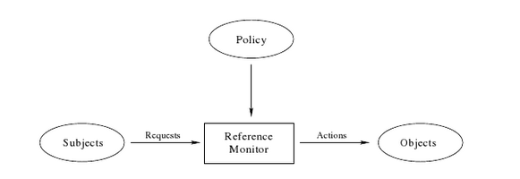

Policy Implementation: Centralised Policy, Decentralised Mechanism
- Client-server architecture: server(s) hosts the security policy for the entire organisation and reference monitors on clients use this policy to make access control decisions.

- Example: Windows NT onwards. The policy can be administered from the server and is upheld by the clients.
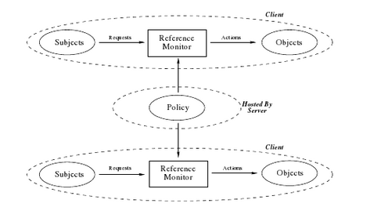

Policy Implementation: Decentralised Policy, Centralised Mechanisms
- Copies and fragments of the policy are distributed across network. Policies may be held by both trusted authorities and by untrusted authorities.

- The enforcement mechanisms must be sure that they reference the complete policy.

- Examples: using cryptographic authorization certiﬁcates that associate some permission with a principal as signed by a trusted authority. X509 authorization certiﬁcates, support for SPKI/SDSI certiﬁcates in MS vista. Examples: X509 authorization certiﬁcates, KeyNote, SPKI/SDSI.
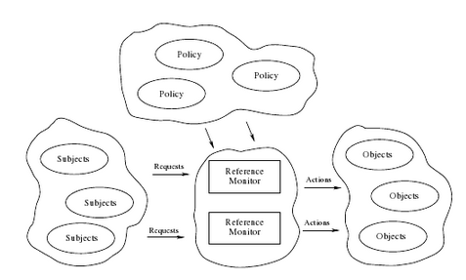

Firewall Configuration
Direction-Oriented Filtering
- Packets claiming to be sourced from the internal network inbound but arriving on an external network interface are considered to be spoofed and such packets should not be permitted by the ﬁrewall.

- The attacker forges packets to reﬂect the source IP addresses that are associated with internal systems so that a ﬁrewall (not conﬁgured with direction-oriented ﬁlter controls) interprets these packets as having originated within the internal network.
  - No way to authenticate IPv4 packets.
  - This type of attack typically forms part of a Denial of Service Attack (DoS) on an internal network.
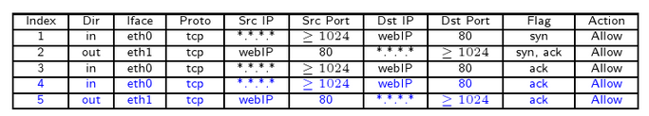

Types of Firewall
- Packet Filter Firewall
- Stateful Firewall
  - Same as packet filter firewall, but saves state(to a degree / where possible). Only packets matching a known active connection will be allowed by the firewall, others will be rejected.
- Application Layer Firewall
  - An application-layer ﬁrewall, while it can examine both network and transport layer packet headers, can also examine a packets payload at the application layer. It provides increased assurance of the validity of packet content.

- From the point of view of the ﬁrewall, the term tunneling refers to the practice of encapsulating data from one protocol inside another protocol in order to evade the ﬁrewall.

A proxy is a system that acts as an intermediary when forwarding packets on behalf of a client system requesting access to a network resource (server).

- A client system establishes a TCP/IP connection with the proxy system when it has a request that is to be forwarded to a server.

- The proxy in turn, contacts the remote server and establishes a secondary TCP/IP connection where the proxy then relays the ongoing communication between the client and server.

- To the client, it appears that there is a direct TCP/IP connection between itself and the server.

- Similarly, the server has no knowledge of the client and communicates with the proxy as if it were the client.

- Each successful connection attempt actually results in the creation of two separate TCP connections, one between the client and the proxy system, and another between the proxy system and the destination server.

- The proxy is transparent to the two end systems (client and server), and from their perspective they are directly connected to one another.

- This provides an additional level of protection to the internal systems because external client systems can only communicate with the proxy and therefore internal IP addresses are not publicly known to the external Internet.

- An application proxy is a proxy that has application-layer ﬁrewall capabilities. Application proxies are systems that specialise in providing access control for a single application protocol, for example, HTTP, FTP or SMTP.

Firewall Conflict Management
Conflicts in Firewall Policies

- Intra-Conflict (conﬂicts that occur between rules on a single ﬁrewall) (RSCGI)
  - intra-, inter-redundancy (where the rules are the same)
    - Equivalence
    - Subsumption

  - intra-, inter-shadowing (where one rule is used before another) (and both rules have different target actions)
    - As a general rule of thumb, one either deletes the intra-shadowed rule or re-orders the two rules, such that the more speciﬁc rule is placed before it’s more general counterpart.

  - intra-, inter-correlation (where two rules partly filter each other) (administrator warning)

  - intra-, inter-generalisation (where two rules have different target actions, and one rule can filter the same packets as the other rule, as a result of being a superset of the other rule) (administrator warning)

  - intra-irrelevance (where a rule cannot match any traﬃc based on either the source and destination IP addresses) (administrator warning as it may add unnecessary ﬁrewall rule lookup overhead)

- Inter-Conflict (conﬂicts that occur between rules across diﬀerent ﬁrewalls)
  - Includes redundancy, shadowing, correlation, generalisation & inter-spuriousness.

  - Inter-Spuriousness (where a downstream ﬁrewall is ﬁltering an equivalent, a subset or superset of packets that an upstream ﬁrewall is currently ﬁltering, but the upstream ﬁrewall is permitting what the downstream ﬁrewall is denying)

SYN Flood
Normally when a client attempts to start a TCP connection to a server, the client and server exchange a series of messages which normally runs like this:

- The client requests a connection by sending a SYN (synchronize) message to the server.
- The server acknowledges this request by sending SYN-ACK back to the client.
- The client responds with an ACK, and the connection is established.

Msg 1 Source → Destination SYN(x)
Msg 2 Destination → Source SYN(y), ACK(x + 1)
Msg 3 Source → Destination ACK(y + 1)

Connection setup (3-way Handshake):
1. Initiator sends SYN
2. Recipient sends SYN/ACK
3. Initiator sends ACK

This is called the TCP three-way handshake, and is the foundation for every connection established using the TCP protocol.

Connection Tear-down (4-way Handshake):
1. Initiator sends FIN/ACK
2. Recipient sends ACK
3. Recipient sends FIN/ACK
4. Initiator sends ACK

A SYN flood attack works by not responding to the server with the expected ACK code. The malicious client can either simply not send the expected ACK, or by spoofing the source IP address in the SYN, causing the server to send the SYN-ACK to a falsified IP address - which will not send an ACK because it "knows" that it never sent a SYN.

Avoiding SYN Flood Attacks
- Reduce the timeout period to a short time, eg 10 seconds to make it harder to maintain the attack window. May deny legitimate access.
- Increase the number of half-open connections allowed (eg use SYN-cache). May increase resource requirements.
- Disable non-essential services in order to reduce the number of ports that can be attacked (part of ‘hardening’ the system).

SYN Cookies
- Provide defence against DDOS attacks.
- The use of SYN cookies allows a server to avoid dropping connections when the SYN queue fills up. Instead, the server behaves as if the SYN queue had been enlarged. The server sends back the appropriate SYN+ACK response to the client but discards the SYN queue entry. If the server then receives a subsequent ACK response from the client, the server is able to reconstruct the SYN queue entry using information encoded in the TCP sequence number.
- This way there is no limit on the number of TCP connections that can be made.

Rich’s Potential Question
(Referring to Syn floods)
Why wouldn’t a digital signature approach work? Digital Signatures would require more resources on the system due to the way they're created using hashing(that could be wrong). If a large number of legitimate requests were sent to the server using this method it would struggle to confirm them all in a reasonable amount of time.

